Go-Back-N ARQ (Solved Problem 2)

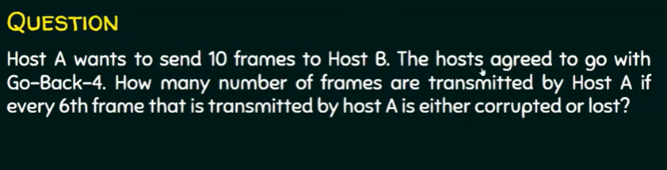

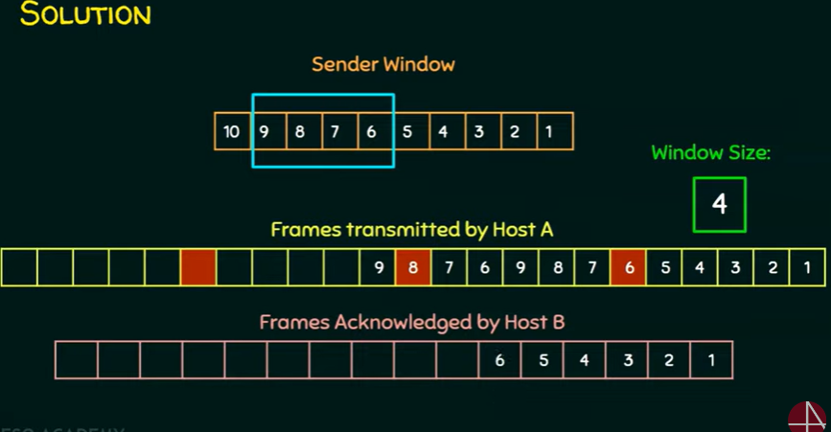

**Answer: 17**